# **Scenario based practical work**

The learner must write a practical work report which will include the following;

1. Aim of the experiment
2. Variables of the experiment

* Independent variable
* Dependent variable
* Controlled variable

1. Hypothesis
2. List of apparatus and materials
3. Procedure of the experiment and setup
4. Presentation of data

* Table of results
* Graphs
* Calculation of the slope

1. Sources of errors
2. Precautions
3. Conclusion

## **Practical work evaluation guide**

|  |  |  |  |  |  |  |
| --- | --- | --- | --- | --- | --- | --- |
|  | **Basis of assessment** | **Code** | **Criteria** | **Score** |  | **Total score** |
| 1 | Aim of the | A | Properly stated aim | 2 | A 2 | 2 |
|  | experiment |  | Partially stated aim | 1 | A 1 |  |
|  |  |  | No or incorrect aim | 0 | A 0 |  |
| 2 | Variables of the | V | Correct independent variables stated | 1 | VI 1 | 3 |
|  | experiment |  | No or incorrect independent variable stated | 0 | VI 0 |  |
|  |  |  | Correct dependent variables stated | 1 | VD 1 |  |
|  |  |  | No or incorrect dependent variable stated | 0 | VD 0 |  |
|  |  |  | Correct control variables stated | 1 | Vc 1 |  |
|  |  |  | No or incorrect control variable stated | 0 | Vc 0 |  |
| 3 | Hypothesis | H | Correct Hypothesis stated | 1 | H 1 | 1 |
|  |  |  | No or incorrect Hypothesis stated | 0 | H 0 |  |
| 4 | List of apparatus and  materials | Ap | All relevant apparatus and materials stated | 2 | Ap 2 | 2 |
|  |  |  | Partially relevant apparatus and materials stated | 1 | Ap 1 |  |
|  |  |  | No or irrelevant apparatus and materials stated | 0 | Ap 0 |  |
| 5 | Procedure of the experiment and setup | PR | All relevant procedures of the experiment and setup stated | 2 | PR 2 | 2 |
|  | Relevancy |  | Partially relevant procedures of the experiment and setup stated | 1 | PR 1 |  |
|  |  |  | No/ irrelevant procedures of the experiment and setup stated | 0 | PR 0 |  |
|  | Coherency | Pc | When procedures of the experiment and setup are coherent | 2 | Pc 2 | 2 |
|  |  |  | When procedures of the experiment and setup are partially coherent | 1 | Pc 1 |  |
|  |  |  | when procedures of the experiment and setup are not coherent | 0 | Pc 0 |  |
| 6 | Sources of errors | ER | Most sources of errors stated (2) | 2 | ER 2 | 2 |
|  |  |  | Few sources of errors stated | 1 | ER 1 |  |
|  |  |  | No or incorrect sources of errors stated | 0 | ER 0 |  |
| 7 | Precaution | Pr | All relevant precautions stated | 2 | Pr 2 | 2 |
|  |  |  | Partially relevant precautions stated | 1 | Pr 1 |  |
|  |  |  | No or incorrect precautions stated | 0 | Pr 0 |  |
| 8 | Presentation of data | Dp | Correct presentation of data | 2 | Dp 2 | 2 |
|  |  |  | Partially correct presentation of data | 1 | Dp 1 |  |
|  |  |  | No or incorrect presentation of data | 0 | Dp 0 |  |
|  | Recording of data | DR | Correct recording of data stated | 2 | DR 2 | 2 |
|  |  |  | Partially correct recording of data | 1 | DR 1 |  |
|  |  |  | No or incorrect recording of data | 0 | DR 0 |  |
|  | Set of data | DS | Maximum set of data stated (3 or more) | 2 | DS 2 | 2 |
|  |  |  | Minimum set of data stated (1) | 1 | DS 1 |  |
|  |  |  | No or incorrect set of data stated | 0 | DS 0 |  |
| 9 | Accuracy of data | AC | Correct accuracy of data stated | 2 | AC 2 | 2 |
|  |  |  | Partially correct accuracy of data stated | 1 | AC 1 |  |
|  |  |  | No or incorrect accuracy of data stated out of range | 0 | AC 0 |  |
| 10 | Data analysis and interpretation | DA | Appropriate method used to process data(s.f and d.p) | 2 | DA 2 | 2 |
|  |  |  | Partially appropriate method used to process data | 1 | DA 1 |  |
|  |  |  | No or incorrect method used to process data | 0 | DA 0 |  |
|  |  | DI | Correct interpretation of data | 2 | DI  2 | 2 |
|  |  |  | Partially correct interpretation of data | 1 | DI 1 |  |
|  |  |  | No or incorrect interpretation of data | 0 | DI 0 |  |
| 11 | Drawing of experiment setup | D | Correct or complete well draw and labelled | 2 | D 2 | 2 |
|  |  |  | Partially labelled | 1 | D 1 |  |
|  |  |  | No or incorrect or wrong drawing | 0 | D 0 |  |
| 12 | Conclusion | C | Well stated conclusion based on interpretation | 2 | C 2 | 2 |
|  |  |  | Partial stated conclusion based on interpretation | 1 | C 1 |  |
|  |  |  | No or incorrect interpretation | 0 | C 0 |  |
| 13 | Advice given | AD | Correct/appropriate/relevant advice given based on finding | 1 | AD 1 | 1 |
|  |  |  | No/incorrect/inappropriate/irrelevant advice given based on finding | 0 | AD 0 |  |

# **SCENARIO BASED PRATICAL EXPERIMENT**

## **Example 1**

Catherine discovered a spring in tool box in the garage and had a labelled on it “spring constant k= 45 kg s−1”. Unfortunately, she doubtful about the value of spring constant. She carried it to school and asked a group of senior three students on how best to prove the spring constant but they didn’t help her.

**Task**

As a physics student, help her solve this problem using a scientific investigation

(Hint *k* *= 1.6 x 103 x 0.5 x S*)

You have been provided with the following apparatus and materials:

1 Retort stand having 2 clamps, 1 spring, 1 metre rule, 1 pointer, 6 mass (100g), 2 piece of wooden clip.

**Expected responses**

**Aim**: An experiment to determine the constant, *k* of the spring.

**Variables of the experiment**

* 1. Independent variable: mass, m
  2. Dependent variable: length, P1, P0, P
  3. Controlled variable: Mass of the spring

**Hypothesis**: The constant, k of the spring is 45 kgs-1

**Apparatus and materials**

1 Retort stand having 2 clamps, 1 spring, 1 metre rule, 1 pointer, 6 mass (100g), 2 piece of wooden clip

**Procedure of the experiment**

1. The spring and metre rule are clamped on retort stand and placed on the table as shown 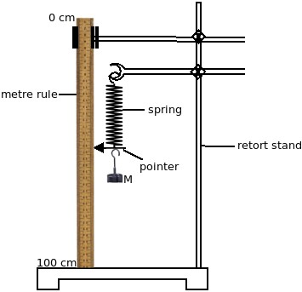
2. The initial position, P0, of the pointer on the vertical metre rule scale placed with the zero mark at the top is read and recorded.
3. The mass, M = 0.10 kg is suspended from the lower hook of the spring.
4. The new position, P1, of the pointer on the vertical metre rule is read and recorded as in (b).
5. Procedures (c) and (d) are repeated with hanging mass m = 0.20, 0.30, 0.40, 0.50, and 0.60 kg on the end of spring.
6. The results are recorded in a suitable table including values of P = P1 - P0 in metres.
7. A graph of M against P is plotted.
8. The slope S of the graph is determined.
9. The spring constant, *k*, is calculated from the expression; *k* *= 1.6 x 103 x 0.5 x S*)

P0 = 60*.*0 cm P0 = 0*.*600 m P1= 62*.*0 cm P1 = 0*.*620 m

**Table of results**

|  |  |  |
| --- | --- | --- |
| m(kg) | P1 (m) | P (m) |
| 0.10 | 0.620 | 0.020 |
| 0.20 | 0.640 | 0.040 |
| 0.30 | 0.660 | 0.060 |
| 0.40 | 0.680 | 0.080 |
| 0.50 | 0.700 | 0.100 |
| 0.60 | 0.720 | 0.120 |

Slope, S = 

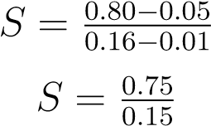

*S* = 5 kg m−1

Constant, 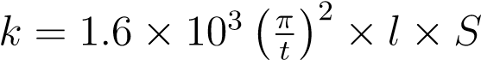

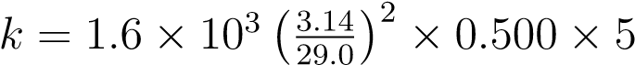

*k* = 46*.*89 kg s−1

**Sources of errors**

* Inaccurate weight of masses given.
* Permanent deformation of the spring hence not obtaining its original length.

**Safety Precautions**

* Do not play around with the masses or spring.
* Be sure that the spring provided can gain its original length.
* Keep a distance from the apparatus.

**A graph of M against x**

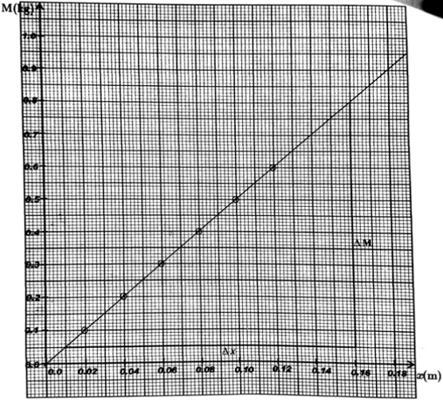

**Conclusion**

In this experiment, I have been successful to prove the aim of the experiment which is Hooke’s law. The results obtained were correct with minimal errors and therefore the slope in the graph indicates the value spring constant, *k* = 46*.*89 kg s−1 which was closed to the labelled value of 45 kg s−1. I feel that my data is reliable and the graph does show that the extension of the spring is directly proportional to the force that is applied to it